Hope for Children International
Email: info@hocicameroon.org website: www.hocicameroon.org

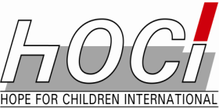

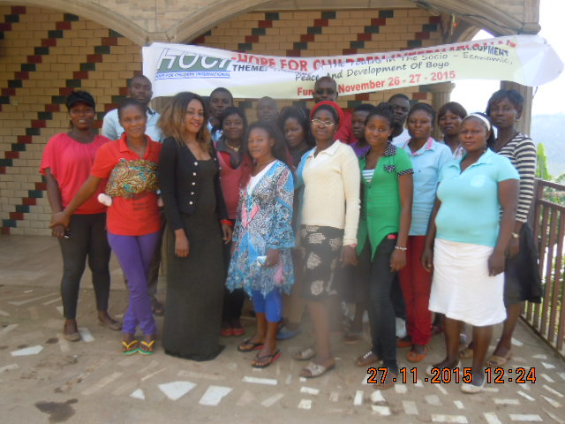

INTRODUCING HANDWASHING WITH SOAP IN NURSERY AND PRIMARY SCHOOLS
2017 REPORT

INTRODUCING HANDWASHING WITH SOAP IN NURSERY AND PRIMARY SCHOOLS
Each year, diarrheal diseases and pneumonia together kill almost 4 million children under five in developing countries. Children from the poorest 20 percent of households are more than 10 times as likely to die as children from the richest 20 percent of households. Hands are the principal carriers of disease-causing germs: if widely practiced - and based on scientific research and intensively monitored trials at both household and school levels - it is estimated that hand washing with soap could avert one million of those deaths. Washing hands with soap after using the toilet or cleaning a child and before handling food can reduce rates of diarrheal disease by nearly one-half and rates of respiratory infection by about one-quarter. Hand washing can also prevent skin infections, eye infections, intestinal worms, SARS, and avian flu. It can also benefit people living with HIV/AIDS.
HOCI then came up with the handwashing with soap project to help combat the spread of these diarrheal infections. Teaching has been designed in pictures to facilitate understanding, coupled with some practical exercises.
HOCI also made it easier for children to be able to own their individual water containers, where they fill them with water each time they are empty. This too is fun for the children as they keep themselves busy. The individual containers are plastic bottles that are easy to obtain. They are hung on an appropriate place where the child can get there easily. Little holes are perforated under the bottle. When filled with water and coked, the water does not leak. But when the coke is slightly opened, water flows out through the holes for the child to wash his hands. Once he finishes, he simply cokes the bottle back. Again this is simple and fun for the children. With the use of these bottles, even children in the poorest community can still practice hand washing with soap without any problems.
HOCI Peer Educators for Life Skills Volunteers (PALSV) are the ones going round the schools and training and implementing this project. They have been trained on the techniques passing on this information to the teachers and pupils. So far the results have been impressive.

