Hope for Children International
Email: info@hocicameroon.org website: www.hocicameroon.org

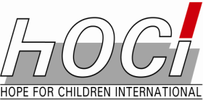

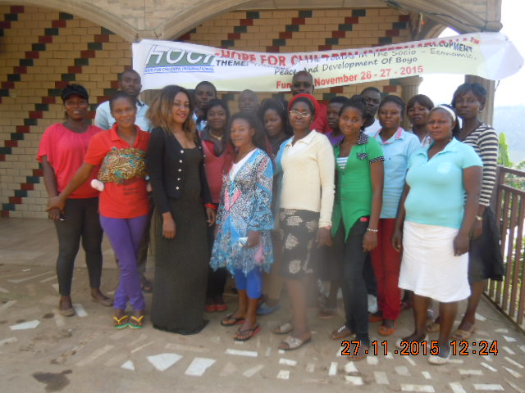

The Njinikom Youths Fund Project

2016 REPORT

Introduction
The rate of unemployment and poverty in Cameroon has forced so many parents to abandon their duties of taking care of their children; paying their school fees and providing food for the family. The consequences of this act are overwhelming. There is an increase in the number of school drop outs leading to the overcrowding of our city centers with idle youths. The results of this idleness are: armed robbery, drugs, alcoholism, rape, early and unwanted pregnancies, increased percentage of the spread of Sexually Transmitted Infections (STIs), HIV/AIDS and other social ills. This of course plays negatively on the country’s economy and renders our communities very vulnerable.
However, some of these youths with the help of Hope for Children International (HOCI) have come together and have formed small groups where they empower themselves and try to pick up the bits and pieces of their lives to put them together again and to move on. This is the case of the Youth groups in Njinikom where they have come together to help each other improve on their standards of living and that of their families and their community. HOCI is now working with four (4) of these groups thus, dealing with about 200 youths directly.
Apart from the farm work that they do together already, and the common grinding mill which they manage, HOCI has came up with this brilliant fundraiser activity “The Njinikom Youth Fund” to raise direct income which they can use to change their lives through small loans and support each other. This involved the building of five solid canopies of 100 sitting places each, buying of 500 plastic chairs, and buying of a complete solid sound system. These items cost four million three hundred and fifty thousand francs (4,350,000 francs). These things generate income every weekend through hiring. The money raised is lodged in an account in a local bank.
BACKGROUND
Youth unemployment in the world is blighting a whole generation of youngsters. The International Labor Organization (ILO) estimates that there are 75million 15-24 year olds looking for work across the globe. An estimated 26million youth are not in Education, Employment or Training. Globally, about 85% of the world’s young people live in developing countries and an increasing number of these young people are growing up in cities. In many cities on the African continent, more than 70% of the inhabitants are under the age of 30 with about 65% of the total population below the age of 35 years making Africa the most youthful continent in the world.
In Cameroon, the unemployment rate is 30% while that of underemployment stands at 75% (International Labor Organization’s 2013 report). It is worth noting that Cameroon has a population of over 20 million inhabitants and most of the people belong to the middle class. The working population of Cameroon is about 12million and only a little over 200,000 people work in the public service. With government being the highest employer, this implies that the other 11.8million people who are not government employed are a call for concern. This is the reason why HOCI came in to support.
Hope for Children International (HOCI) in a bit to fulfill its goals and objectives, started the reorganization of the youths of the Boyo Division of the North West Region. In the course of the first ever Boyo Youth Forum that held in Fundong from November 26 -27, 2015, the idea to create a “The Njinikom Youths Fund” came up. To make this fund functional, this project was born to add to the farming and grinding mill projects that existed already. The project falls within goal one of the HOCI framework which is to promote Healthy Lifestyles and Life Skills within the youths.

The purpose of the Project
The money raised from the hiring of these equipments goes into a fund called “The Njinikom Youths Fund”. This fund does the following:
- Help the youths who are drop outs especially the girls to go back to school;
- It also helps those who want to learn a trade to pay for their training;
- It also helps those who want to start small businesses to so.
All those who benefit from this scheme, pay in a certain percentage of their profit into the account so as to permit the others to also benefit.
Project Execution
The project is coordinated and run by the local bureau of HOCI which was put in place after the Boyo Youth Forum that took place from the 26-27 of November 2015. It is supervised and controlled by HOCI CEO. The bank account that was opened in a local bank in place bares three signatures; that of the coordinator, the Financial Secretary and the Treasurer. Money can only be withdrawn from this account with the authorization of the CEO after examination of the files that have been transmitted to them.
However, the Local bureau keeps the equipment; transport them to and from the ceremonial grounds. Payment is done before the equipment leaves the HOCI premises and a duly signed and stamped receipt issued to the person concerned and the duplicates kept safely for accountability. There is a control every end of the month to see what came in and how much was deposited in the account. This is to avoid any mismanagement of the funds raised.

The expected impact of the project
- The Njinikom population and that of Boyo Division shall be served with services that the lone service provider in the area could not provide, so breaking the monopoly and the high prizes and poor services that accompanied this.
- The youths shall gain financial autonomy that will help some of them go back to school, and also help others start up other small businesses, and improve on their standards of living and that their families and the general population of the Sub-Division.
- This will not only empower the youths, but it will also lighten up the burden of the parents who in many cases have so many children and no source of income to take care of them.
- This community will naturally see an increase in its development and a decrease in the social ills and spread of diseases such as HIV/AIDS, early pregnancies, school drop outs, crime wave, etc since the majority of the youths will now be occupied and responsible.
- This will reduce massive exodus of youths wanting to leave the village for greener pastures elsewhere. This project will give them the opportunity to create their own businesses and get trained in professions of their choice with funds from the project.
Sustainability and Continuity
HOCI put in place very strong control mechanisms to control the running of this project. A secretariat was put in place and various people trained for various task.
- There is someone with the sole responsibility of receiving customers and their requests. These requests are registered and payments made. Receipts are issued upon payments and the duplicates kept for control. The money collected is deposited in the account the same day.
- There is another person who is in charge of the store. He is the keeper of the materials. He only delivers whatever has been requested upon presentation of the receipt. He also keeps a register for whatever goes out and the state at which the things are returned. This is to make sure we don’t lose any of the items.
- There is a trained technician to manage the canopies and the sound system. He controls them before they take them out and does same when they return them. He is also the main operator of the sound system.
- Any equipment that is destroyed is paid for by the person who hired the equipment. This is the reason why a caution is deposited at the time of hiring and only reimbursed when the manager confirms the equipment has been returned and in good order.
- At the end of every month, there is a control team that comes in to check to the accounts of the month. The team controls whether what came in was deposited in the account and on time, and also control the state of the equipments. The more funds raised shall permit that more equipment be bought and other services added to what exists already. This of course will ensure proper sustainability and continuity and more youths will benefit from this.
Ayeah James Yongabi
CEO HOCI

