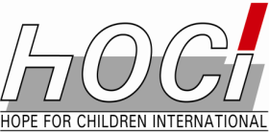
HOPE FOR CHILDREN INTERNATIONAL

Youths and SPORTS FOR LIFE SKILLS, CIVIC EDUCATION, and BEHAVIOUR CHANGE TRAINING

SIMBOCK YAOUNDE
JUNE 1 TO 22, 2021

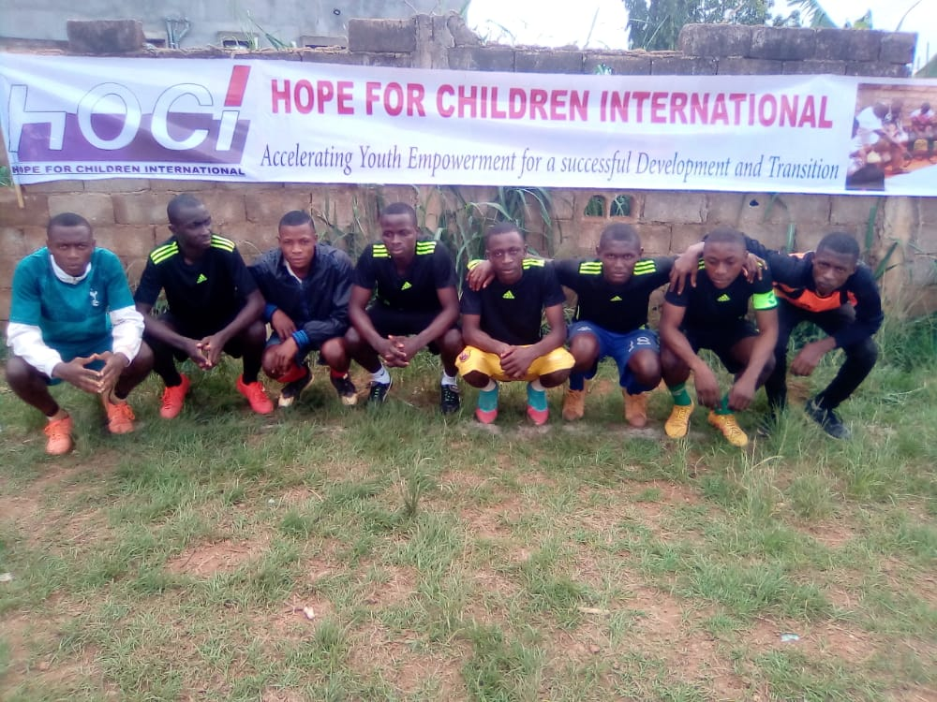

REPORT OF ACTIVITIES

From June 1 to 22, 2021 in the Simbock neighbourhood in Yaounde, HOCI organized a sports competition between out of school youths. The sports competition which was essentially made up of football, was to serve as a motivation for youths to come out in their numbers and receive training on Life Skills and Civic Education for Behaviour change. After the competition, the first two teams become automatically the “Youth Ambassadors” of the local area. The players and their coaches shall be trained as Peer Educators, who will continue with the animation of the youths in the local area.
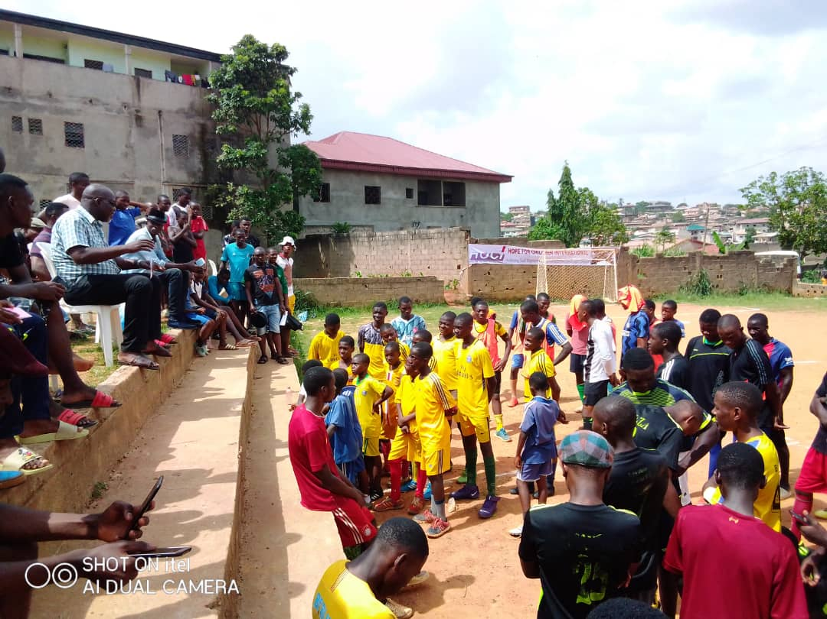
WHY THE PROJECT? OUR MOTIVATION
- Nobody has ever been born a good citizen or a nation born democratic
- It is a process of evolution that continues all through one’s life
- Any nation that ignores the youths during this process of evolution is cutting off an important umbilical cord for development and transformation.
- The project is particularly geared towards teaching principles and cultivating attitudes
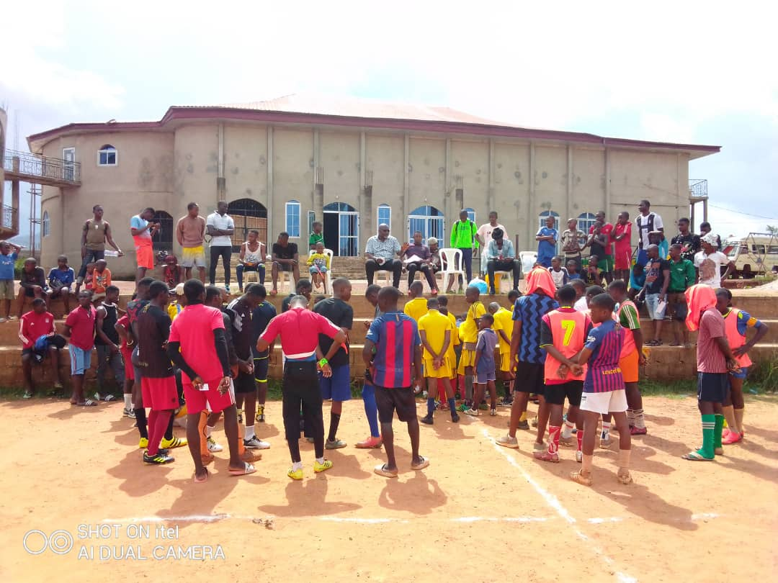
GOALS
- The main goal of this project is to engage 1000 youths between the ages of 10-35 in some Regions of Cameroon in constructive healthy, social and sports activities as one aspect of healthy personal development
- Using sports to teach youths the principles of teamwork, self-control, and respect for their opponents.
- To use sports as an enabler to improve youth physical and social health, promote volunteerism, social cohesion, among youths in Cameroon

THE ACTIVITY
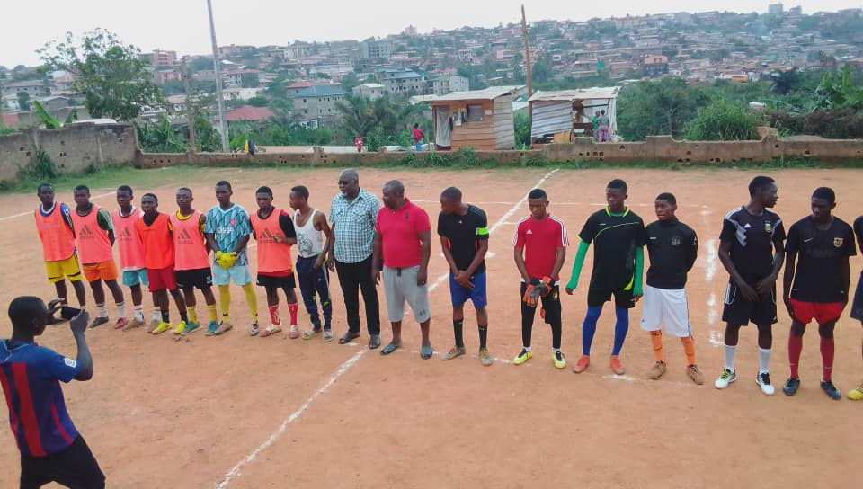
- Seven (7) teams of 15 players each registered for the competition;
- Matches were scheduled for every Saturday from June 1 to 22, 2021;
- One hour before each match, there were talks
Topics handled during the period of the competition are:
- Personal Responsibility. In sports, each player must strive through self-discipline to contribute his or her strengths to the team and overcome individual weaknesses
- Each player must play a position and avoid usurping a fellow player's role. Thus, the players experience a sense of peace within their own hearts and minds as they perform their jobs well. This can be translated to fit into rights, roles and responsibilities of a good citizen.
- Self-Control. In sports, players improve their mind-body coordination and learn to have better self-control, both on and off the field.

- Respecting and relying on others. In sports, players use teamwork and learn to value each other. From practicing teamwork, they learn how to commit themselves to a cause and to be reliable and loyal
- Maximizing joy in life. When team members play well together, there is harmony and great excitement. Players should challenge the world to share that joy, to join with them to bring development and peace.
- A low-cost and high-impact tool in humanitarian, development and peace-building efforts
- It attracts, mobilizes and inspires
- It is about participation, inclusion and citizenship
- It stands for human values such as respect for the opponent, acceptance of binding rules, teamwork and fairness
- It is a promoter of social integration and economic development in different geographical, cultural and political contexts
- a powerful tool to strengthen social ties and networks, and to promote ideals of peace, fraternity, solidarity, non-violence, tolerance and justice
- It teaches the essential values and life skills including self-confidence, teamwork, communication, inclusion, discipline, respect, Health and disease prevention, Promotes gender equality, Peace building and conflict prevention/resolution, and fair play.

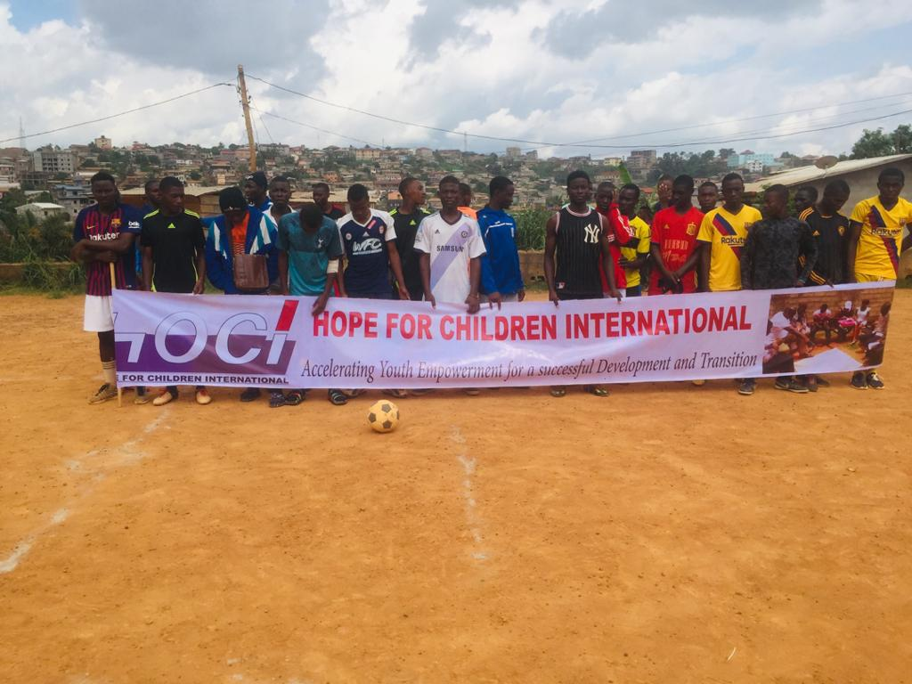

II: The responsibilities of citizens(youths)
- Sources of responsibility
- Know and respect the law
- Know and respect your rights
- Respect the Authority
- Know the Republican Institutions and the Constitution
- Participate in the collective life of your community
- Participate in the electoral process
- Respect the opinion of others
- Respect sociocultural norms
- Know and respect national symbols
- Know and respect the various Republican Institutions (Executive Power, Judiciary Power, Legislative Power)
- The Presidential System in Cameroon
- Peace and Security (conditions for the culture of peace, strategies for peace, tolerance, security, insecurity, causes of insecurity)
- Participation of youths in community development (local government, civil society)
III: LIFE SKILLS
- Communication skills
- Critical Thinking skills
- Decision making skills
- Relationship skills
- Peer Pressure

PART TWO OF THE PROJECT: TRAINING OF PEER EDUCATORS
The first two teams of the competition automatically become “The Youth Ambassadors of the Quarter. The players together with their coaches are trained as Peer Educators and at the end of their training, they shall receive certificates. They shall henceforth be the leaders and trainers of the youths in the local area. The training takes three days.

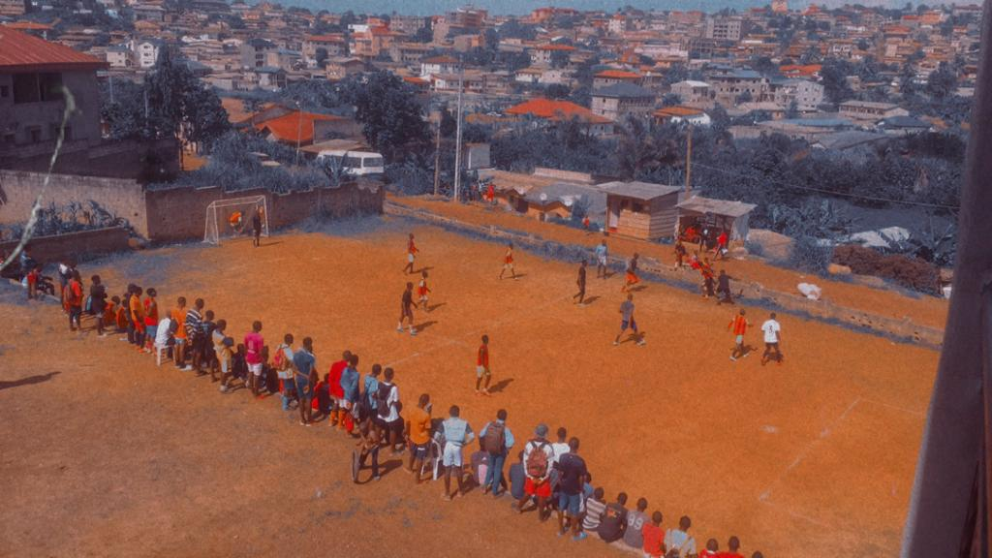
Email: info@hocicameroon.org website: www.hocicameroon.org
Accelerating Youth Empowerment for a successful Development and Transition

